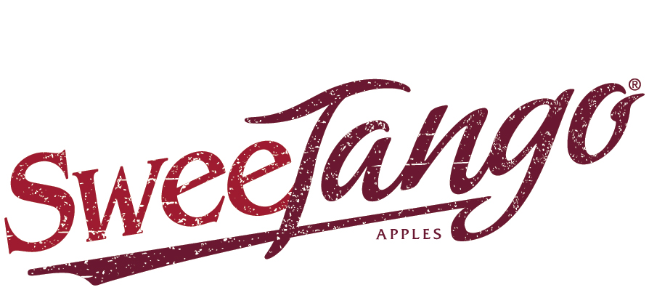
CONTACT:
Julia Stewart for Fiction Tribe
jstewart@prclarity.com
(703) 727-8808 cell

FOR IMMEDIATE RELEASE

COORDINATED MARKETING FUELS RECORD SWEETANGO APPLE SALES

Swedesboro, N.J. (Dec. 8, 2020) – A coordinated strategy of aggressive retail push and consumer pull activities has already driven sales of 2020-crop SweeTango® apples to the top of the charts this season, growers of the managed variety report. And given the exceptional quality of this year’s SweeTango crop, they are urging retailers to get on board now for a strong season finish.

According to Nielsen scan data, SweeTango is among the top three managed apple varieties this season, notable for a variety that is still seasonal. Growers and packers with the Next Big Thing, A Growers Cooperative pointed to this year’s fruit quality, and the loyal fan base the apple has built since it first hit the market in limited quantities in 2009.

“The fact that this apple with limited but growing volumes has this much demand, that just speaks to its future,” said former retailer Roger Pepperl with Western region SweeTango marketing and sales lead Stemilt Growers. He urged retailers to “jump on this SweeTango train, and get your consumers on board. It is going to be their favorite apple!”

“This apple’s eating quality coming out of storage is exceptional this year, I’m eating even more of them now than I did right off the trees. And our movement proves the quality. We’re running 18 percent over last year’s sales to date,” said Scott Swindeman with Midwest region SweeTango lead Applewood Fresh Growers.

“This is definitely the variety to stock this year. Consumers are more engaged than we’ve seen! They are going out of their way to send us compliments, and we are staying busy replying to them,” said Austin Fowler of Fowler Farms, which leads SweeTango sales in the Eastern region.

That fruit quality has created new opportunities for retailers. “Retail demand is up this year. Because of this excellent quality and the buzz behind it, we’ve been able to add new customers,” noted John Cushing of New York Apple Sales.

To drive sales this season, the SweeTango cooperative has deployed a range of marketing activities adapted for COVID times. Packers have added a 3-pound pouch to the brand’s usual 2-pound pack and bulk fruit offerings, for today’s consumers who are shopping less often but filling larger baskets. To push sales through retail, the brand’s regional sales desks have worked with grocery partners to showcase the fan-favorite apple to both online and in-store shoppers.

“We have had great support from our retailers this season, putting SweeTangos front and center. We’ve backstopped them with a full court press designed to drive consumers to purchase. This coordinated push-pull strategy is rewarding everyone – growers, retailers and consumers,” said Jennifer Parkhill, executive director of Next Big Thing, A Growers’ Cooperative.

To pull through consumer sales at this unusual time, the brand has executed broad-ranging outreach, online, on air and in print, wherever consumers are. Online, a tongue-in-cheek series of YouTube videos, “History Bites”, have racked up more than 1 million viewer impressions each month since they debuted early this fall. Mobile ads are targeting consumers who have intent to purchase, already converting intent more than 5,000 times. Meanwhile, billboard advertisements are appearing in key markets.

SweeTango is also tapping into the power of influencers. The Produce Moms’ Lori Taylor, has been talking up SweeTango’s flavor, family-friendliness and health-protecting benefits to both retailers and consumers.

The brand refreshed its website SweeTango.com, including adding a real-time product locator that has already fueled 5,000 visitor searches. Meanwhile, social media audience engagement is up more than 60 percent compared to last season.

“We have a record crop, and now record sales – well ahead of previous years here in Canada. The unmatched quality and eating experience of this variety, along with a refreshed go-to-market strategy, has brought new retailers and new consumers to the party,” summed up Dennis MacPherson with Canadian marketing and sales lead Scotian Gold. “We are super excited about where things are headed.”

EDITORS, DOWNLOAD HIGH-RESOLUTION ARTWORK HERE TO ACCOMPANY YOUR COVERAGE OF THIS NEWS:
- SweeTango® color logo
- 2-pound and 3-pound pouch bags
- Billboard advertisement

ABOUT NEXT BIG THING, A GROWERS’ COOPERATIVE
Next Big Thing, A Growers’ Cooperative is a member cooperative of more than 50 family growers, spread over five time zones from Nova Scotia to Washington state. The co-op licenses, grows and markets premium, managed varieties of apples, beginning with SweeTango®.

ABOUT SWEETANGO® APPLES
SweeTango’s signature taste, texture and quality stem from careful breeding, meticulously-selected growing locations and expert horticultural practices. Expert apple breeders at the University of Minnesota crossed the sweet Honeycrisp and the tangy Zestar! varieties to create SweeTango’s more complex, crowd-pleasing flavor profile: sweet, with a touch of citrus, honey and spice. First introduced at retail in the United States and Canada in 2009 and supported by coordinated strategic marketing, this brand has grown into a top-5 trademark apple. SweeTango is a registered trademark of Regents of the University of Minnesota. More information on SweeTango can be found at www.sweetango.com or on Facebook at www.facebook.com/sweetango.

###

